 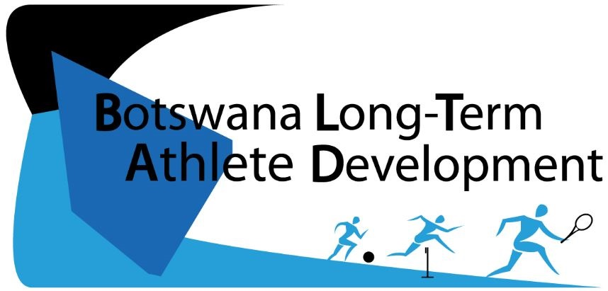

Botswana Long Term Athlete Development



**Building Tomorrow Starts Today**

*A framework to guide taekwondo in Botswana towards lifelong participation and excellence at all levels: from grassroots to podium and beyond.*

**RING TO GOLD**

**TAEKWONDO**

**Created: 2016**

**Created: 2016**

**TABLE OF CONTENTS**

1. **BLTAD Taekwondo Ring to Gold: Preface…………………………………….13**
2. **BLTAD Taekwondo Ring to Gold: Overview………………………………….14**
3. **Early Childhood Development : FUNdamentals………………......………. 15**
4. **Grassroots: Early Specialization……………………………………………...….17**
5. **Cadet: Competition………………………………………....………………………20**
6. **Junior: Learn to Win…………………………..….…………………………………23**
7. **Senior: Elite………………….……………………………………………………….. 26**
8. **Veteran: Mentor…………………………………………………………………….. 29**
9. **All Ages: Taekwondo For Life…………………………………………………….30**
10. **Athlete with Disabilities (AWD)………………………………………………… 31**
11. **Stakeholder Collaboration………………………………………………………. 32**
12. **References.…………………………………………………………………………... 33**

**Expert Working Group**

1. **Mr. Vinay Naicker : President, BTF**
2. **Ms. Gladys Njoroge : Technical Director, BTF**
3. **Mr. Modise Mgadla : Liaison Officer-SD&TS, BNOC**
4. **Mr. Andrew Badeau : QESI/BLTAD intern**

**Key Terms**

**AFTU**- African Taekwondo Union

**BTF** - Botswana Taekwondo Federation  
**BNSC-** Botswana National Sport Commission  
**BNOC –** Botswana National Olympic Committee

**BOPSSA** – Botswana Primary School Sports Association  
**BISA –** Botswana Integrated Sports Association  
**BOTESSA** – Botswana Tertiarty School Sport Association  
**CHOPS –** Conference Heads of Private Schools  
**CHIPS –** Conference Heads of Independent Schools

**COSATA**- Congress of Southern African Taekwondo Association

**ECD**- Early Childhood Development  
**MYSC**- Minister of Youth Sport and Culture

**ISSSA –** Independent Secondary School Sports Association

**QESI-** Queen Elizabeth Scholars Initiative

**WTF**- World Taekwondo Federation

**Key Stakeholders**

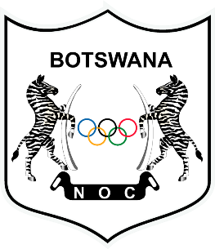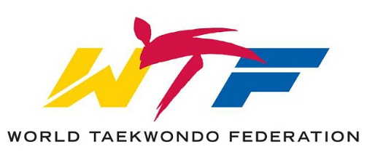

**B**otwana **L**ong **T**erm **A**thlete **D**evelopment

**TAEKWONDO – RING TO GOLD**

**Preface**

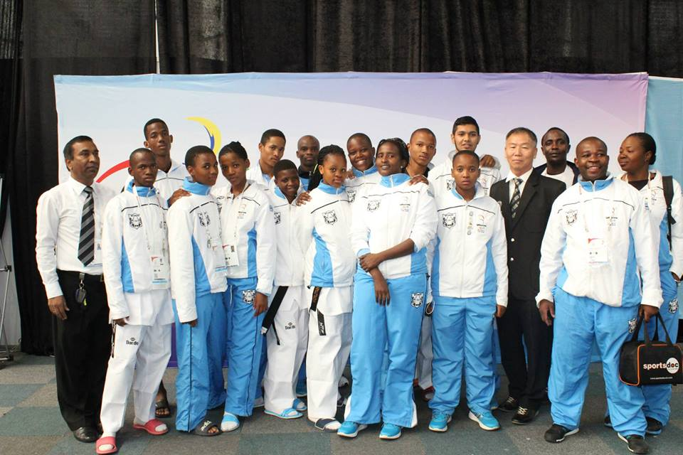 Taekwondo in Botswana under the umbrella of the Botswana Taekwondo Federation (BTF), has experienced exceptional growth through the past decade. With hundreds of students enrolled and multiple coaches certified every year, Taekwondo is promising to be one of the most popular sports in Botswana.

With such a large pool of participants, the BTF understands the need for a structured framework. A well-defined BLTAD framework is essential in order to identify talent, sustain higher participation rates, and train medal hopefuls for international success. The BTF has barely scratched the surface of its potential.

With so many participants signing up every year, shouldn’t Botswana be providing athletes to send to the Olympics? How will the BTF attract athletes from every region of the country? These are two of many reasons the BTF believes a framework is essential.

**THE BLTAD**

BLTAD is a sports development framework modelled after Canadian Sport for Life’s (CS4L), LTAD. Created in 2005, LTAD is a world renowned program, designed to promote lifelong participation and harness sporting success. Botswana Long Term Athlete Development (BLTAD) is a framework developed by the Botswana National Olympic Committee (BNOC) in order to develop, grow, and modify the sports system in the country of Botswana. Since its establishment, the BNOC has grown to accommodate over 30 different sporting federations.

Due to the outstanding growth of enrolment in Taekwondo programs, the BTF feel that it is important to establish a sport specific BLTAD framework. This framework will outline the necessary steps in order to successfully implement BLTAD. Analysis will be provided of the current system and important stakeholders will be outlined. Current challenges will be analysed and necessary solutions provided. Our sport specific model is designed to provide a unique framework which outlines guidelines for each age group.

**BLTAD TAEKWONDO: RING TO GOLD**

The Taekwondo BLTAD provides age-appropriate guidelines for training and comeptitions for every age group. The goal of this framework is to guide athletes towards long term participation and/or success from grassroots to the podium and beyond via the Ring to Gold.

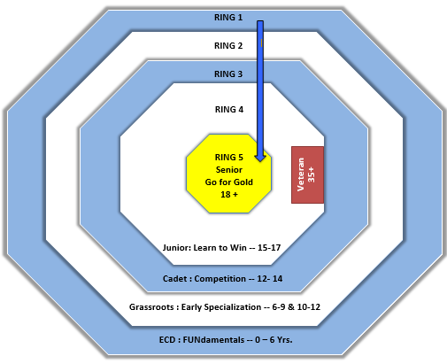

**RING 1:   
ECD/PRE SCHOOL**

**0-6:** Multi-sport games focusing on sport skills and FUNdamental movements.

**RING 2:   
GRASSROOTS/LOWER-UPPER PRIMARY**

**6-9 & 10-12:** Emphasis on physical literacy in combination with sport specific taekwondo skills

**RING 3:   
CADET/JUNIOR SECONDARY**

**12-14:** Introduction to formalized competition and ring management

**RING 4:   
JUNIOR/JUNIOR-SENIOR SECONDARY**

**15-17:** Advanced taekwondo techniques fostered through local, national, and international competition

**RING 5:**

**ELITE/SENIOR SECONDARY**

**18+:** International competition and high performance specialized training

**Figure 1**

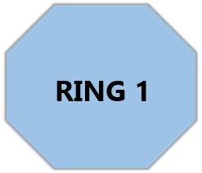

**ECD : FUNdamentals**

**Ages: 0 – 6 ECD  
School: Pre-school**

**Objective:** Develop fundamental athletic skills in an unstructured, fun environment. Provide an inclusive program to encourage social interaction.

This is the introductory phase of the Ring to Gold. At the moment, this is a **very important phase** of the BTF’s BLTAD framework. Although the hope is for an increase in Taekwondo participation, it is also important for children to sample different sports and **develop necessary FUNdamental skills and sports knowledge** through exploration. It is important that **fun and social interaction** are the **focal point** of this stage. The goal is for participants to enjoy the sport and not feel as though they are forced into participation.

**GUIDELINES**

**Key Stakeholders/Programs:** BTF, BNOC, BNSC, WTF, BOPSSA, MYSC

**Types of Training:** Assorted sporting activities, fun, games

**Skills to Train:** FUNdamental movement, flexibility, balance, hand-eye coordination, teamwork

**Types of Competition:** Minimal competition. Any competition must be unstructured and inclusive to all participants**.** The competition level should be very low. Modified rules should be encouraged to promote a higher participation rate.

**Number of Sports:** Multiple (encourage fundamental sports – athletics, gymnastics, swimming)

**Duration of Training:** 45 min

**Taekwondo Programming Frequency:**  2 sessions per week

**Non-Taekwondo Programming Frequency:** 1-3 sessions per week

**Duration Per Year:** At this stage, any taekwondo training takes place in the school system. It occurs during each school term. Ocassional holiday programming and camps arise.

Competition is **discouraged** in this stage. Although competition is an important element for athletic progression, it can be disheartening at this age. **Elimination and winning is not important** at this stage. The focus of early childhood development sports is **to learn and develop fundamental skills** which will help the athlete **foster growth** in the future. There are **too many risks involved** in competition at such a young age. Examples include injury, learning improper form, and discouragment from the sport.

**Competition Design:**

* Modified rules
* Creative structure
* Mass Participation  
   (VS Elimination)
* Games
* No individual recognition/prizes

**ECD COMPETITION**

**Physical Literacy:**

Physical literacy is a very important element of the long term development pathway. A great deal of research that has been conducted has determined that a substantial amount of time in the early period of life (0-8 years) should be devoted to developing overall movement skills. If the sport becomes specizlized too early in the development process, the athlete could risk missing out on crucial training of skills such as balance and coordination. Coaches and important stakeholders must understand the importance of a strong sporting base before they can specialize in a particular sport. A list of the fundamental movement skills has been provided in Appendix 2.

**Injury prevention:**

Injuries can occur in any ring of the Ring to Gold framework. It is very important that all coaches and relevant stakeholders promote the importance of warming up and stretching before participating in any sporting activities. Almost all injuries associated with the sport can be prevented if athletes are prepared for the activity and exercise safe behaviour. All instructors should be certified in first aid training and provide all relevant first aid materials in their teaching environment to promote the uttmost safety. Some of the most common taekwondo injuries are sprained ankle/knee, broken fingers/toes, and bruising from repeated or improper contact. A list of taekwondo specific stretching exercises is provided in ***Appendix 4***. A combination of an adequate warm up and cool down period will limit the risk of injury significantly.

**Role of Important Stakeholders:**

As mentioned previously, this is a very important age for the practice and development of FUNdamental skills. Therefore, it is integral that parents, child care-givers and early childhood educators foster the improvement of these skills through games and “free play”. Skills cannot be learned overnight. The BTF must closely involve parents, child care-givers and early childhood educators in the process and keep them informed.

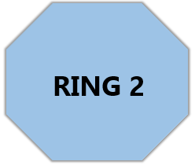

**Grassroots: Early Specialization**

**Objective:** Develop sport-specific taekwondo skills in an organized, fun environment.

**Ages: 6 – 9 Child 1   
School: Lower Primary**

**Ages: 10-12 Child 2   
School: Upper Primary**

This is the second ring of the **Ring to Gold**. Children in the grassroots phase are still learning **fundamental skills** and developing **physical literacy**. **Competition** is introduced in this phase in order to allow athletes to get accustomed to participating in events**.** This stage helps to prepare participants to develop necessary **foundation and sport specific skills** in order to progress into national competitions at the cadet level. Children 6-9 will compete in the same categories, regardless of gender. However, as students progress into the Child 2 section(10-12), they will be competing against their own gender and weight class.

**GUIDELINES**

**Key Stakeholders/Programs:** BTF, WTF, BNOC, BNSC, BOPSSA, MYSC

**Types of Training:** Sport specific drills, target striking, defensive footwork, rinq ettiquette, rules/regulations of taekwondo, poomsae training, breaking, demonstration, taekwondo aerobics

**Skills to Train:** Basic/Intermediate Kicks, Strikes, Stance, Blocks, Tenets, Self-Defence

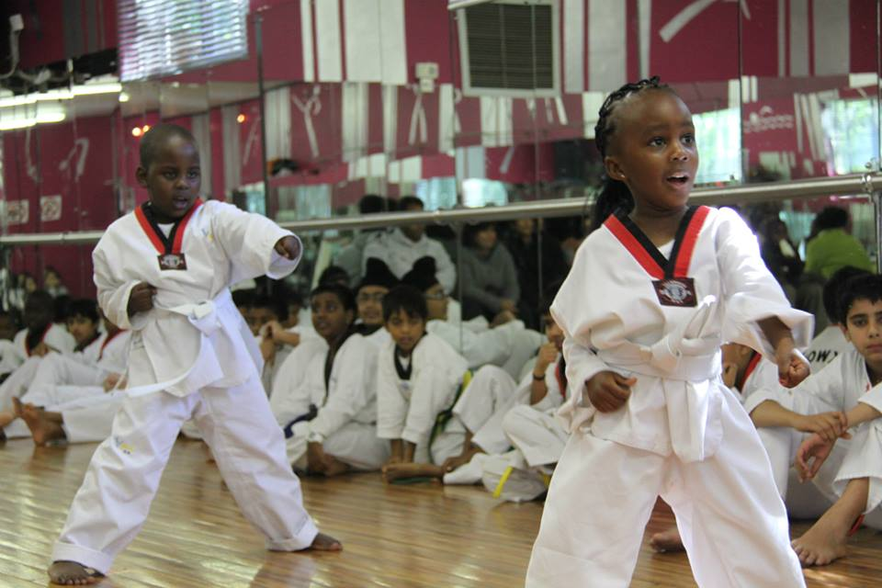**Types of Competition:** Local competition. In Child 1 section, all genders compete against each other. In Child 2 section, genders are seperated

**Ancillary Sports:** Recommended sports include football, athletics, swimming, gymnastics

**Duration of Taekwondo Training:** 60 min

**Taekwondo Programming Frequency:** 3 sessions per week

**Non-Taekwondo Programming Frequency:** 2-3 sessions per week

**Duration Per Year:** At this stage, any taekwondo training takes place in the school system. It occurs during each school term.

**GRASSROOTS TRAINING CONSIDERATIONS**

Children in this ring experience rapid growth in terms of **mental capacity**, **coordination** and **motor skills**. This is the ideal stage to be teaching the necessary fundamental skills.

**Physical development** as a whole, is at a much **slower pace.** Strength, conditioning, and stamina all progress at low levels.

**Boys** and **girls** will progress mentally and physically at **different stages** so it is important to provide an **inclusive** and **encouraging** environment to both genders.

* **FUNdamental Movement Skills (FMS)** In this age group, athletes should be taught the the ABC’s of FUNdamental Movement Skills: Agility, Balance, and Coordination. Particularily important skills would be balancing, kicking, dodging etc. (See Appendix 2)
* **Early Specialization** Taekwondo is an “early specialization” sport and therefore emphasizes introduction of specific sport skills at an early age. Becoming an expert in taekwondo requires years of practice and technique.

**Child 2 (10-12)** is considered the **“Golden Age of Learning”**

* **FUNdamental Sport Skills (FSS)** Athletes should still be encouraged to participate in the *foundation sports* (athletics, gymnastics, swimming). These sports in congruence with Taekwondo lessons, will help improve hand eye coordination, balance, and other important skills to foster future sports success.
* **Fitness:** This is an important age to encourage an active lifestyle. Early introduction into sport is a key element for continued enrollment. If sports are seen as fun, participation rates will remain high.

**PSYCHO-SOCIAL CHARACTERISTICS**

|  |  |
| --- | --- |
| Attention Span | Children in the grassroots stage typically cannot sit still or follow direction for a long period of time. It is of uttmost importance to make the rules and directions of the activity as simple as possible. Encourage children to imitate and practice movements in order to determine whether they are listening (e.g. ‘Simon Says’). |
| Reasoning Ability | Children **enjoy being led** and thrive in a structured environment. Ensure that **lessons are repeated** multiple times in order to **encourage improvement** and measure performance goals. |
| Everyone learns differently | Children often absorb information and **learn through different methods**. Some may prefer **visual learning** (acting out, signs) while others are more **verbal learners**. It is important for coaches to **switch up their methods** and be able to recognize those who might be struggling with current methods. |
| Let Imagination Roam Free | Children are gifted with an **incredible imagination** so it is important to allow for a **creative and welcoming environment**. Encourage students to **suggest new rules** or add a **different twist** on activities. Switch up activities frequently in order to **keep children guessing** |
| Parents Are Important | Kids look to their parents for **guidance and mentorship**. Parents are encouraged to **promote sports** and the importance of an **active lifestyle**. **Parents must be informed during** the sporting process and are encouraged to **practice activities at home** with children (i.e hopping, playing footbal etc.). |

**GRASSROOTS COMPETITION**

The major focus of grassroots competition is to prepare the athletes on how to compete. Through small, inclusive, local competitions, athletes are able to test out their current knowledge and gain a better grasp of the rules and ettiquete of Taekwondo. The goal of these competitions is not to win but rather to put the fundmental skills they have learned into action. Athletes will be trained in both sparring, poomsae, and breaking, and taekwondo demonstration.

**Competition Design:**

* Ring Rules (Dojang)
* Ring Ettiquette
* Modified rules for Child 1 group
* Simultaneous particpation in other sports
* Competition walk-throughs/simulations
* Mass Participation

**Team Selection:**

Team selection can be a major issue at early stages of Grassroots development. Team selection often takes place early into a school term or season. This can be an issue for those participants who might develop at a slower pace. In the end, the grassroots phase is designed to learn and practice the necessary movement skills. Athletes may become discouraged from the team selection process which could end up costing the BTF talented future participants. The following characteristics should apply to team selection. Please refer to Appendix 3 for more information and graphic representation.

* Emphasize participation and inclusion; avoid team selection if possible
* If team selection is necessary, provide multiple team options for development (A team, B team, practice squad etc.)
* Cycle the athletes chosen for teams to accommodate those who havent had a chance to compete

**Coach Recogntion:**

Every coach is important in the development of an athlete throughout their career. Often we see the grassroots/junior coaches neglected when recogntion is provided. We must ensure that each coach is commended for their efforts.

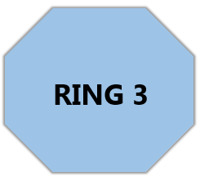

**Cadet : Competition**

**Ages: 12 - 14  
School: Junior Secondary**

**Objective:** Competition and sport specific training. Technical drills and ring management

This is the third stage of the **Ring to Gold**. Once in the 12-14 age group, athletes must continue to develop **sports specific techniques** to taekwondo (footwork, kicks application and poomsae). There is a greater emphasis in this stage on preparations for **national competitions** and the development of **winning strategies and techniques**. Cadet is a very important stage because it serves as a **gateway** to further national competitions and serves as an excellent time period to **identify potential talent**.

**GUIDELINES**

**Key Stakeholders:** BTF, BNSC, WTF, BNOC, BOPSSA, MYSC

**Types of Training:** Combination of sport specific drills (kicks, punches, defence) and ring management (instruction and practice of rules, match timing etc.)

**Skills to Train:** Increased repertoire of kicks, punches, dodges, and flexibility exercises

**Types of Competition:** Local, National, and International. Introductory competition with an emphasis on ring management, understanding of rules and regulations and how to conduct yourself in a match

**Number of Sports:** 1

**Duration of Taekwondo Training:** 60 min

**Frequency of Taekwondo Programming:** 5 sessions per week

**Frequency of Non- Taekwondo Programming:** 2 sessions per week

**Duration Per Year:** At this stage, Taekwondo training continues to take place in the school system. It occurs during each school term. There are also various local and national competitions hosted throughout the year. Holiday camps and programming are quite common.

**Table 1**

**Training Principles**

1) Overload

2) FITT (Frequency, intensity, type, time)

3) Progression

4) Specificity

5) Reversibility

6) Rest-Effort balance

7) Variety growth

**CADET TRAINING CONSIDERATIONS**

* In accordance with the **seven training principles** (table 1), athletes should begin to promote **fitness and proper nutrition** in order to foster **physical growth.**
* Emphais on **sport specific** skills demonstrated in Taekwondo. Athletes should now be able to properly execute all **common strikes and defensive manouvers** with ease.
* Athletes should participate in activities that provide insight into the actual competition itself. **Ring management** and **rules/guidelines** of the sport should be emphasized.
* Childrens flexibility decreases as they experience physical growth. **Limberness and flexibility** should be highlighted as key elements of a succesful taekwondo competitor. **Stretching and flexbility** should be incorporated prior to and in conclusion of training or competition.

(BNOC, 2015)

**PSYCHO-SOCIAL CHARACTERISTICS**

|  |  |
| --- | --- |
| Maturity | Confusion and anxiety levels are quite high at this stage. Therefore, athletes who may in fact have a high maturity level, might not act like it. Coaches must emphasize the importance of quality communication skills and provide support to those who may experience anxiety. |
| Fear of Failure | **Egocentric** **thought** is heightened during this stage. Due to the mental influence it can cause participants to have an increased **compete level** but also develop a **stronger fear of failure**. It is important for the coach to emphasize the value of **confidence** and the fact that failure can be a **positive mechanism for growth**. |
| Hormonal Effects | Youths in this age group are experiencing a significant ammount of **hormonal development** and **mental growth**. The increased hormone levels might cause **mood swings** and **uncommon behaviour** between athletes. It is integral for the coach to foster an environment that provides **two way communication** and involves athletes in the **decision making** process. |

**CADET COMPETITION**

The goal of competition in the Cadet stage is to educate athletes on how to compete. Competition experience will be worthwhile for athletes when they start to look into the national level competitions. Although winning and success are emphasized in this stage, the main element the BTF is looking for at this stage is preparation. Along with the skills that are practiced daily, having a strong knowledge of how to compete will be a major asset.

Competition at the cadet stage takes place at the local level in schools. Certain national competitions are also held throughout the year. It is important that athletes sent to these competitions are properly prepared on what to expect at the national level. By the end of this stage, each athlete should be adept at understanding the official WTF and Olympic rules and regulations of Taekwondo. Practice with the electronic scoring system and official WTF referees are also ideal in this stage.

**PROGRAM CONSIDERATIONS**

**Team Selection**

Similar to the grassroots level, it is important to delay team selection for as long as possible. Since development occurs at different paces for each individual, time must be provided to properly assess the talent pool. Since athletes are more hormonal at this stage, any discouragement could cause mood swings and result in drop outs.

The following characteristics should apply to team selection:

* Emphasize participation and inclusion; avoid team selection if possible
* If team selection is necessary, provide multiple team options for development (A team, B team, practice squad etc.)
* Cycle the athletes chosen for teams to accommodate those who havent had a chance to compete (Move from Team A to Team B etc.)

**Talent Identification**

Since Taekwondo is an early specialization sport, there are a few differences from the standard BLTAD model. With regards to talent identification, Taekwondo begins to identify at an earlier age group than recommended. Recently, the WTF has begun to identify the Cadet age group and sanction competitions every year. These competitions provide an excellent opportunity to scout talent.

Although talent identification is important, there are a few key elements to consider in the process. The first important element is that current talent is much different than potential talent. Those who are stronger or more flexible at this age might have an advantage. As mentioned previously, technique is an integral element of Taekwondo. An athlete who is physically stronger at the current stage might have an advantage but it doesn’t mean that they will fare better in future competition than an athlete with flawless technique and form.

Strength and size may be deceiving when identifying talent. It is important to consider those who have quality technique and are mentally tough in competition in the process as well. Since all of these athletes are still developing physically and mentally, it is important not to discount any particular participant.

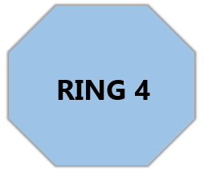

**Junior : Learn to Win**

**Ages: 15 - 17  
School: Jr. & Sr. Secondary**

**Objective:** National competition. Increased sport specific development to foster Olympic berths

The athletes are now entering the fourth ring of the **Ring to Gold**. At this stage, the athletes have now learned the necessary skills and prepared for **high performance competition**. There are many different competitions available at this level. It is important to ensure that athletes have a strong knowledge of the sport, necessary skills, and **repetoire of techniques** in order to experience success in the senior stage. The junior stage provides another opportunity to identify the athletes with the **highest talent potential** in future competitions. Athletes who have enrolled in taekwondo training from the grassroots level until the junior stage will have a tremendous advantage.

**GUIDELINES**

**Key Stakeholders:** BTF, BNSC, WTF, BNOC, BOPSSA, MYSC

**Types of Training:** Competition simulation, sparring, advanced target striking, mental competition preparation, warm-up/cool down,

**Skills to Train:** Advanced taekwondo specific skills, fitness progression, mental fortittude/competitive drive.

**Types of Competition:** Local, National and International Competitions

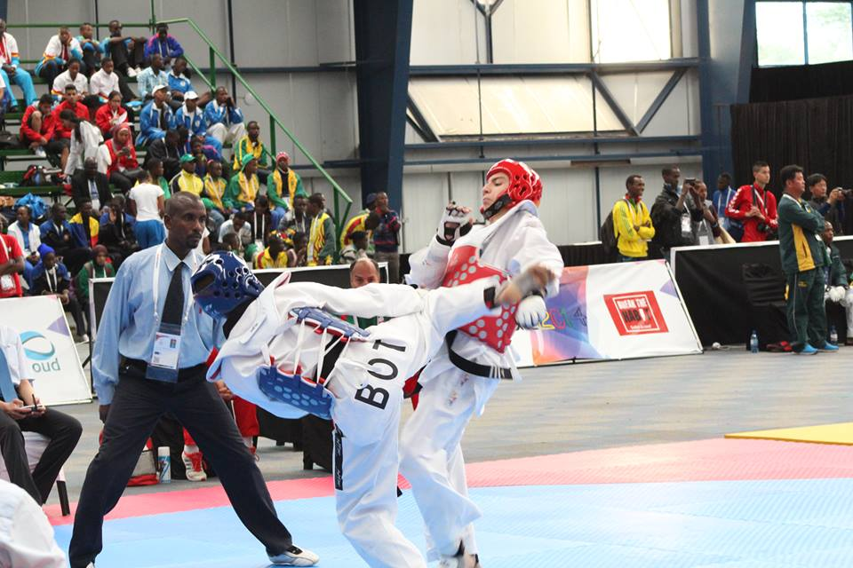**Number of Sports:** 1

**Duration of Training:** 60 – 120 min

**Frequency per Week:** 4-6 sessions

**Frequency of Other Sports per Week:** 1 session

**Duration Per Year:** At this age, athletes are still training through school programs. However, the majority of growth is seen in external training programs with high performance coaches.

**PSYCHO-SOCIAL CHARACTERISTICS**

|  |  |
| --- | --- |
| Critical Thinking | Although the brain is still maturing for years to come, critical thinking is well ingrained into athletes in this stage. It is important to provide a challenge to each athlete. Providing a challenging environment will promote quality decision making and emphasize critical thinking. Being able to make informed decisions is a tremendous asset in competition. |
| Self Awareness | **Self-awareness, self-analysis,** and **self-correction** should be promoted to each athlete in this stage. Being self aware will help an athlete understand why a **problem** occurs with their technique and guide the **self-correction** process. |
| Self Image | **Self image** and **self esteem** are important elements of this stage. Athletes experience **confidence issues** due to **hormonal** **spikes**. It is key to emphasize the importance of a **healthy lifestyle** and promote healthy **nutrition** and **fitness.** |
| Independence | Promote **independence** within each athlete in order to decrease **reliance** on **support network**. Teach **time management** skills such as how to balance **school, career, and sport**. |
| Masculinity | Female participants must understand that male athletes now deal with the problem of relating their performance to masculinity. |
| Femininitiy | Male participants must understand that female athletes now deal with the problem of femininity versus sport development. |

**JUNIOR TRAINING CONSIDERATIONS**

**Figure 2**

**PHYSICAL**

**10 Components of Fitness (S’s)**

1. Stamina (Endurance)
2. Strength
3. Speed
4. Skill
5. Suppleness (Flexibility)
6. Structure or stature (physical/anthropometric)
7. (p)Sychology
8. Sustenance (i.e., nutrition, hydration, rest, sleep etc.)
9. Schooling
10. Socio-cultural aspects

* Taekwondo training should be a **formal** process including a **warm** **up**, the training session, and a **cool** **down** period
* Ensure **Ten Components of Fitness (S’s)** and **7 Training Principles** are integrated into daily routine (See table 1 & figure 2)
* **Competitions** should occur **frequently** at this stage in order to put skills to the test
* **Physical fitness training** tailored to the needs of taekwondo
* **Advance pyschological skills** and **integrated support servies,** (i.e., physiotherapy, nutritionist, psycholoist, etc.,)

BNOC, 2015

**NOTE**: Each component of fitness(S’s) is **‘TRAINABLE’**. Each skill can be improved upon or decline. Ensure that each component is given equal importance to prevent decline.

**JUNIOR COMPETITION**

**Strive for Success**

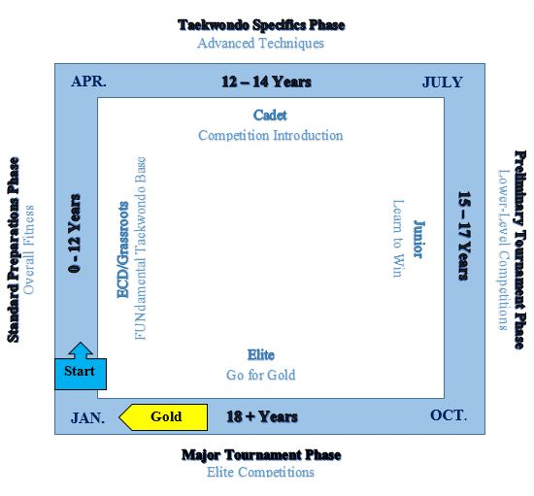Although every competition is important at the Junior Stage, it is important to build a sustainable plan. If an athlete competes in every tournament and tries to win at all costs, they could risk burnout of injury. Based upon the magnitude of each competition and qualifying standards, each athlete must develop a strategy for long term success.

If an athlete hopes to be successful in elite high performance competition they must first learn how to win at all levels. As seen in figure 3, the athlete should aim to peak in the Major Tournament Phase. The three previous stages should serve as extra development and exposure.

The hope of junior competition is that it will prepare each athlete for high performance at the Elite Level. Competitions provide the highest quality experience and will teach athletes to win when it counts. There must be a good balance of competition, training, and rest. Overworking athletes could cause mental or physical burnout so caution is recommended with each athlete.

**Figure 3**

**Available Competition:**

* Junior World Taekwondo Championships
* Youth Olympics
* African Youth Games
* Continental Championships
* Regional Games (COSSASA)
* Local Games

**Talent Identification:**

At this stage it will become more evident who the strongest athletes are in each weight division. Rather than focusing on participation, smaller teams should now be selected in this stage. It is important to once again note that mental and cognitive strengths are an important element of team selection. Examples of this being competitiveness, motivation, and sportsmanship. The full list of identifiers are outlined in Appendix 4. Although a particular athlete may perform well in preliminary action, competition provides another perspective that must be included in the evaluation process.

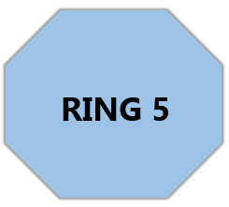

**Senior : Elite**

**Objective:** Achieve success in international competitions and bring home medals to Botswana

**Ages: 18 +  
School: Sr. Secondary**

This is the **final ring** of the athlete’s competitive career. To this point, athletes have learned the FUNdamentals (Ring 1), developed sport specific skills (Ring 2), practiced competition techniques (Ring 3), and learned how to win (Ring 4). It is now time to **increase fitness levels, improve mental toughness and fine-tune their taekwondo technique**.

**GUIDELINES**

**Key Stakeholders:** BTF, BOTESSA, BNOC, WTF, BNSC, IOC, MYSC

**Types of Training:** Advanced techniques, competition simulations, sparring. Major focus of training is to maximize performance in competition.

**Skills to Train:** Fine tuning taekwondo skills, optimizing mental toughness, and improving fitness levels

**Types of Competition:** Competition excellence at the elite level. World Championships & Olympics

**Number of Sports:** 1

**Duration of Training:** 60 – 180 min

**Frequency per Week:** 5-6 days

**Frequency of Other Sports per Week:**  1 day

**Duration Per Year:** Athletes should train year-round. Provide a mix of techniques and training methods to increase skill reppitoire and decrease likelihood of mental or physical burnout

**SENIOR TRAINING CONSIDERATIONS**

**PHYSICAL**

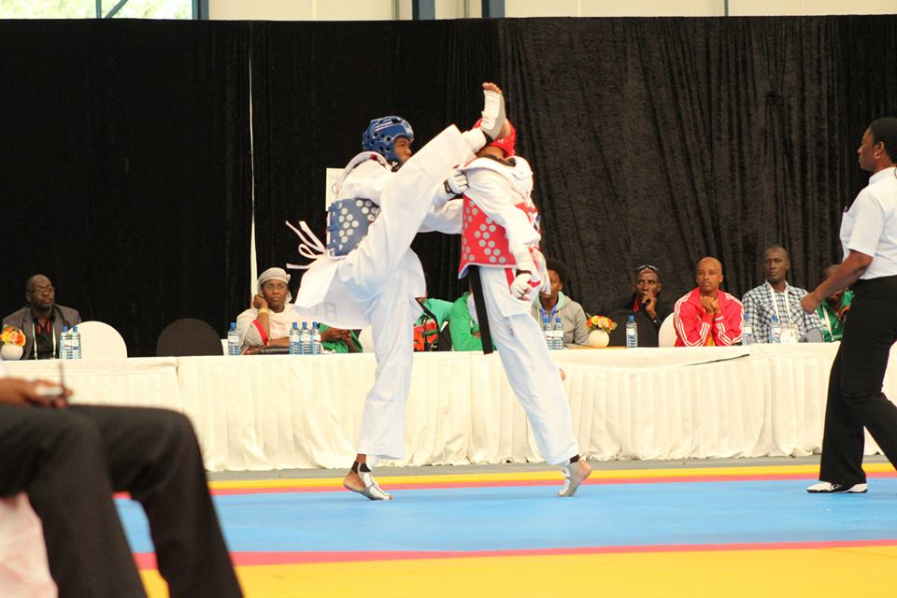

* **Advanced taekwondo training:**  Training sessions incorporating warm-up, taekwondo specific training, and cool down while following upon the 7 key factors of training.
* **Physical fitness training:** Should be tailored to the needs of taekwondo. Combination of strength and cardiovascular exercise.
* **Advanced competition training:** Tournament walkthroughs, simulations and sparring exercises should be put forth in combination with real high performance. .competitions

**PSYCHO-SOCIAL CHARACTERISTICS**

|  |  |
| --- | --- |
| Pyschological skills | In this stage, advanced psychological skills should be incorporated into every competition and training exercise. Some of the most important psychological skills to note are imagery, goal setting, perseverance, and leadership. |
| Mental Support | Athletes at this age are juggling many **responsibilities** at home, in their social life, and in their career. It is important for the BTF to provide necessary **guidance** through the use of **inegrated support services** like **physioterapy, sport psychology, career guidance counseling, post secondary tutoring** etc.). |
| Public Image | Because athletes will be representing the BTF and themselves on the world stage, it is important that they are trained in **public speaking and media management**. Not only that, athletes should also be educated on **doping proceudres and anti-doping laws**. |
| Life Balance | Athletes at this stage spend a great deal of time training and competing in competitions. Therefore, it is important that all **stakeholders** (family, coaches, teachers) provide **necessary** support. The skill of **time** **management** should be promoted and practiced by each athlete in order to ensure there are no **distractions** when it comes time to compete. |
| Athlete Lifestyle | At this stage, elite athletes are often traveling for competition and training. **Traveling abroad** poses many **challenges** (i.e. culture shock, financial exchange, homesickness etc.). |

**SENIOR COMPETITION**

The goal of competition in the senior stage is to go for gold. All the work that has been done previously has led to this point. It is now time to execute on the international stage. It is important that each athlete is aware of their skill set and recognize when mistakes are made in competition. The ability to bounce back from mistakes and improve is what sets the top athletes apart. There is always room for improvement, especially in taekwondo.

The ratio of competition to training should be about 75%-25% at this point. Competition will outline the skills that need to be practiced or improved upon. It is important to outline a schedule of competitions that will avoid mental and physical burnout.

For a sample competition training guide refer to Appendix 5. This is the training plan that was used succesfully by the Junior Taekwondo Team at the 2014 2nd African Youth Games in Gaborone.

**Available Competition:**

* Olympics
* World Taekwondo Championship
* World Team Championship
* World Poomsae Championship
* World Grand-Prix
* Local Games
* Regional Games
* World Para Championships
* World Taekwondo Beach Championship
* Commonwealth Games
* Military Games
* Inter-Varsity Games

**ATHLETE RETIREMENT**

Although there are many competitions available at the veteran level (35+), it is quite common for taekwondo athletes to retire before they reach that level. Although it seems like an easy process, it can be very stressful for the athlete and governing body. If an athlete has been focused on taekwondo for the majority of their life it could leave that particular athlete without necessary skills to excel in the workforce.

Athletes need to be properly prepared for life after competition. This can be anything from financial planning to post-secondary education. Stakeholders serve an important purpose in guiding the athlete through the transition. There are valuable life skills taught in taekwondo (discipline, time management, confidence). These skills combined with a structured career pathway will make the transition much easier.

**Veteran : Mentor**

**Ages: 35+  
School: N/A**

**Objective:** Competition and transition into coaching/management of the sport

This is the final stage of the athlete’s competitive career. For Taekwondo athletes can still compete in the veteran age groups. Athletes in this stage are looking to compete and master their craft. There are opportunies available in coaching, management, refereeing, and officiating upon retirement from competition. Due to the multitude of experience and mastery of technique it is advisable for the BTF to consider integrating former competitors into coaching, officiating, and refereeing.

**GUIDELINES**

**Key Stakeholders:** BTF, BOTESSA, BNOC, WTF, MYSC

**Types of Training:** Advanced technique and sport specific drills

**Skills to Train:** Mastery of technique, officiating/refereeing principles, management guidelines, coaching certifications, designing of coaching programs

**Types of Competition:** Various sparring and poomsae competitions

**Number of Sports:** 4

**Duration of Training:** 60 min

**Frequency per Week:** 2-3 days

**Frequency of Other Sports per Week:** 3 days

**Duration Per Year:** Personal preference of the athlete

**All Ages : Taekwondo for Life**

**Objective:** Enjoying a healthy and active lifestyle to accomplish physical, emotional, social, and career goals

**Ages: Any  
School: N/A**

It is important to note that only 1% of all athletes actually move onto Olympic competition. The majority of the population is looking to find physical activities to socialize, stay fit, and keep mentally strong. Taekwondo serves as an ideal sporting activity due to its regemented schedule and structure. Although high performance sport is integral to the BTF, there must still be a focus on the general public.

**GUIDELINES**

**Key Stakeholders:** BTF, BOTESSA, BNOC, WTF, BNSC, MYSC

**Types of Training:** Casual taekwondo course enrollment, range from basic to advanced material.

**Skills to Train:** Flexibility, cardiovascular endurance, hand eye coodrination, life skills, discipline

**Types of Competition:** Amateur competition and unstructured recreational practice

**Number of Sports:** Multiple

**Duration of Training:** 60 min

**Frequency per Week:** 2-3 days

**Frequency of Other Sports per Week:** 6 days

**Duration Per Year:** Personal prefernece of the athlete. Scheduling conflicts due to school and career

*“****Highly competitive*** *and* ***life-long non-competitive*** *sport and physical activity are equally as important and valuable to individual growth and development of all Batswana”* – (BNOC, 2015)

**ATHLETES WITH DISABILITIES (AWD)**

There must be special consideration provided in each stage of the BLTAD Taekwondo model to those with disabilities. Coaches and managers must be educated on the development process of those with disabilities in comparison to other athletes. The BTF aims to provide and inclusive program to every athlete in Botswana, regardless of their disability. The guidelines for accomodating athletes with disabilities have been provided for each stage below:

**Early Childhood Development (ECD) – 0-6 Years**

There are no specific guidelines to follow in this particular stage. Since ECD is focused on having fun and developing basic motor skills, all participants are encouraged to explore their physical capabilities. Those with disabilities are encouraged to try new things and stretch the limits of their mobility.

**Child 1– 6-9 Years**

At this stage, AWD’s are encouraged to continue developing their motor skills in an unstructured environment. Each athlete should be taught the basic foundations of training and recovery in this stage, regardless of disability. There will most likely be a learning curve for those with disabilities so it is important that coaches and staff encourage and provide support to all athletes.

**Child 2 - 10-12 Years**

In this stage, AWD’s should be introduced to the necessary equipment they would need to participate with their disability.

**Cadet – 12-14 Years & Junior – 15-17 Years**

In the Cadet and Junior stages, AWD’s should follow the same training principles as non-disabled athletes. AWD’s should particiapte in any available competitons and follow the same training to competition ratios as non-disabled athletes. Along with local competitions, AWD’s should also be informed of and pracitce the Paralympic Committee and Deaf-Taekwondo rules and guidelines for competition and classification.

**Senior – 18+**

Athletes with or without disabilities should all be following the same guidelines and training regiments for high performance competition. With World Championships and Paralympic events available in all the same disciplines, coaches should put an equal emphasis on every athlete in competition and training.

**Veteran – 35+**

Veteran athletes who have competed or trained with a disability should serve as advocates for those with disabilities in Taekwondo. The sharing of knowledge and training techniques to better help those with disabilities is very important.

**COLLABORATION: FROM THE TOP DOWN**

Although stakeholders on the ground (parents, teachers, and coaches) have immediate impact on the athlete’s development, this is guided by the stakeholders at the top (team management, national federations, government, etc.).

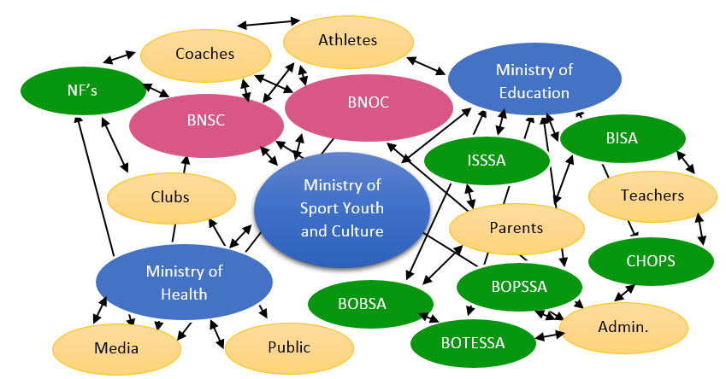

**THE BLTAD  
 A collaboration   
 among all   
 Batswana to foster   
 an active and   
 competitive   
 nation**

**Figure 4**

**Brown, 2014**

Although a coach may emphasize the philosophy of development before results, the governing body may pay or recognize their performance based on results. This could cause the coach to move away from development. In addition, many federations promote BLTAD, yet reward results. Therefore, it is crucial that all stakeholders are on the same page.

Coaches should be recognized on the performance of their objective: development. Results should be a secondary element in this process. Consistency is one of the most important elements of a successful BLTAD framework.

**Role of Governing Bodies:**

* Provide education to stakeholders on ground and at the top
* Implement age-appropriate program structure
* Implement age-appropriate competition structure
* Develop a national structure that provides a clear pathway of progression from grassroots to podium and beyond
* Appropriate and standardized talent identification and selection
* Align polices and age-appropriate funding/recognition
* Stakeholder alignment
* Send a consistent message

**Appendix 1**

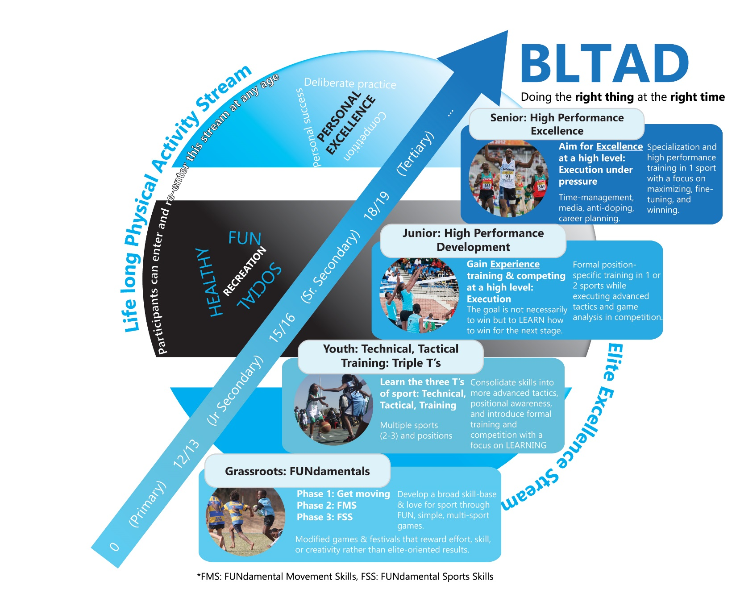

**Appendix 2**

|  |  |  |
| --- | --- | --- |
| Examples of FUNdamental Movement Skills | | |
| Locomotion Skills | **Object Control Skillls** | **Balance Skills** |
| Running (forward & backward)  Jumping  Hopping (one foot, two foot)  Skiping Crawling  Crab Walking  Leaping Climbing Galloping Bounding  Swinging Wheeling  Log roll | Kicking Punching  Rolling (ball) Sticking object (moving)  Striking Object (stationary)  Throwing  Catching Stopping/Trapping Dribbling (with feet) Dribbling (with hands) Blocking Aiming  Two hand strike (bat) | Balancing/Centering  Rolling (somersault)  Dodging  Floating Landing  Squatting-balancing  Sinking (in water)  Falling (through Air) Spinning Stopping Stretching  Swinging Twisitng Standing on hands and head |

**Appendix 3**

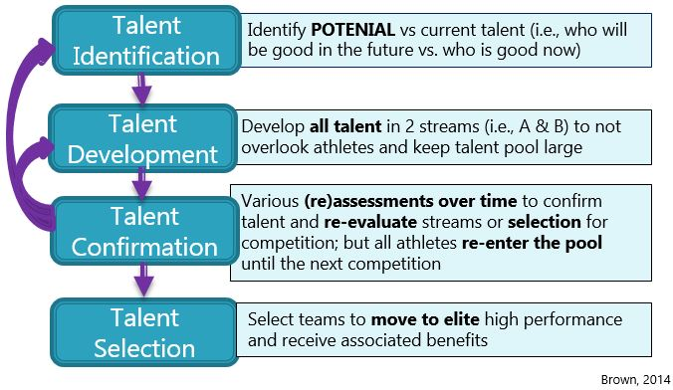

**Appendix 4**

|  |  |
| --- | --- |
| Stretches | |
| One Person | **Two Person** |
| Hurdler’s stretches  Front Spread  Lotus Knee Press  Side Split  Back Arch  Body Rock  Body Tuck  Knee Twist  Knee Bends  Leg Stretch  Trunk Twist  Waist Twist  Side Stretch  Chest Stretch  Neck Roll  Front Side Split  Back Side Split  Waist Twist  Windmills | Two person side split  Body fold  Leg raise  Back stretch  Sit ups |

**Talent Identification**

|  |  |  |
| --- | --- | --- |
| **Potential Talent** | | |
| Ability to learn a new skills | Innovation | Confidence |
| Responsiveness to training | Problem Solving Skills | Concentration |
| FMS/FSS | Decision Making Skills | Determination |
| Sense of observation | Adaptive Strategies | Perseverance |
| Sense of judgement | Willing to improve (growth vs win) | Environmental/social factors |
| Tactical Awareness | Attitude | Self-management |
| Spatial Awareness | Sportsmanship | Self-awareness |
| Effort | Responsibility | Enjoyment (intrinsic motivation) |

**Appendix 5**

|  |  |  |  |
| --- | --- | --- | --- |
| Taekwondo Training Camp (2 week plan) | | | |
| **Target** | **Day 1** | **Day 2** | **Day 3** |
| Physical Conditioning |  |  |  |
| Muscular Endurance |  |  |  |
| Muscular Strength |  |  |  |
| Flexibility |  |  |  |
| Agility |  |  |  |
| Power |  |  |  |
| Speed |  |  |  |
| Basic Kicks and Steps |  |  |  |
| Knee and Step Sparring |  |  |  |
| Pads Kicking |  |  |  |
| Paddle Sparring |  |  |  |
| Running Forward Kicks |  |  |  |
| Running Sparring |  |  |  |
| Kick-Bag Sparring |  |  |  |
| Advanced Kicking |  |  |  |
| Chest-Pad Training |  |  |  |
| Free Sparring |  |  |  |
| Full Contact Sparring |  |  |  |

**Appendix 6**

|  |  |
| --- | --- |
| Basic Techniques | |
| Stance | **Blocks** |
| Guard Position  Attention Stance  Ready Stance  Horseback Riding Stance  Forward Stance  Back Stance  Twist Stance  Walking Stance  Tiger Stance  Fighting Stance | Rising Block  Down Block  Inner Block  Outer Block  X Block  Reverse Outer Arm Block  Knife-Hand Block  Double Knife Block  Palm Block |

|  |  |
| --- | --- |
| Self Defence | |
| Attacks(Jireugi) | **Strikes(Chigi)** |
| Method  Right Punching  Opposite Punching  Erected Fist Punching  Reversed Fist Punching  Target  Trunk Punching  Lower Part Punching  Direction  Side Punching  Spinal Punching  Downward Punching  Upwards Punching | Target  Face hitting  Trunk hitting  Directions  Front Hitting |

|  |  |  |
| --- | --- | --- |
| Kicks | | |
| Basic | **Intermediate** | **Advanced** |
| Front Kick  Round House Kick  Side Kick  Push Kick  Back Kick  Rising Kick  Crossing Kick  Hook Kick | Axe Kick  Jump Front Kick – Front Leg  Jump Front Kick – Back Leg  45 Degree Jump Front Kick  Sliding Front Kick  Sliding Roundhouse Kick  Jump Roundhouse – Front Leg  Jump Roundhouse – Back Leg  45 Degree Jump  Step Back Side Kick  Sliding Side Kick  Jump Side Kick – Front Leg  Jump Side Kick – Back Leg  45 Degree Jump Side Kick  Half Moon Kick  Spinning Kick  Step Back Spin Kick  Inside Crescent Kick  Outside Crescent Kick  Step Back Crescent Kick  Thunder Kick | Jumping Kick  Double Round Kick  360 Turn Round Kick  Sliding Kicks  45 Degree Jumping Kicks  540 Degree Kick  Demo Kicks |

|  |  |
| --- | --- |
| Punches (Strikes) | |
| The Tae Kwon Do Fist  The Knife-Hand  The Ridge-Hand  The Spear Fingers  The Knuckle-Fist | Straight Punching  Side Punch  Jab Punch  Reverse Punch  Double Punch  Knife-Hand Strike  Spear Fingers Strike |

|  |  |  |
| --- | --- | --- |
| Blocks (Defence) | | |
| The parts of blocking | **Method** | |
| Face blocking  Trunk blocking  Underneath blocking  Direction  Inner blocking  Outer blocking  Side blocking | | Twisting blocking  Assisting blocking  Pushing blocking  Pressing blocking  Lift up blocking  Raising blocking  Counter blocking  Cross blocking  Kick up blocking  Outer kick blocking  Push off blocking  Parts of usage  Outer wrist blocking  Inner wrist blocking  Wrist back blocking  Hand-blade back blocking  Hand –blade blocking  One hand-blade blocking  Bent wrist blocking  Palm hand blocking  Foot blade blocking  Foot blade back blocking  Footback kick away blocking  Shin push out blocking |

|  |
| --- |
| Kicking Combinations |
| Front Kick – Sliding Front Kick  Roundhouse – Sliding Roundhouse Kick  Side Kick- Back Side Kick  Inside Crescent – Sliding Inside Twist Kick  Side Kick – Back Side Kick  Roundhouse – Back Spin Kick  Front Kick – Jump Front Kick  Roundhouse – Jump Roundhouse  Own Combinations |

|  |
| --- |
| Etiquette |
| Posture  Entering/Exiting the Dojang  Addressing  Uniform |

|  |
| --- |
| Tenets of Taekwondo |
| Courtesy (Ye Ui)  Indomitable Spirit (Baekjul Boolgool)  Integrity (Yom Chi)  Perseverance (In Nae)  Self-Control (Guk Gi) |

|  |
| --- |
| General Dojang Rules |
| The first is safety  The second is efficiency |

|  |  |
| --- | --- |
| Belt System | |
| Colour | **Assessment** |
| White (10th Gup)  Yellow Strip (9th Gup)  Yellow (8th Gup)  Green Stripe (7th Gup)  Green (6th Gup)  Blue Stirpe (5th Gup)  Blue (4th Gup)  Red Stripe (3rd Gup)  Red (2nd Gup)  National Black (1st Gup)  Poom/Dan (Kukkiwon) | Il Jang  Ee Jang  Sam Jang  Sa Jang  Oh Jang  Yuk Jang  Chil Jang  Pal Jang |

|  |  |  |
| --- | --- | --- |
| Cadet Divisions (Aged 12-14) | | |
| Weight Class | Males | Females |
| Under 33 kg | Not exceeding 33 kg | Not exceeding 29 kg |
| Under 37 kg | Over 33 kg | Over 29 kg and not exceeding 33 kg |
| Under 41 kg | Over 37 kg and not exceeding 41 kg | Over 33 kg and not exceeding 37 kg |
| Under 45 kg | Over 41 kg and not exceeding 45 kg | Over 37 kg and not exceeding 41 kg |
| Under 49 kg | Over 45 kg and not exceeding 49 kg | Over 41 kg and not exceeding 44 kg |
| Under 53 kg | Over 49 kg and not exceeding 53 kg | Over 44 kg and not exceeding 47 kg |
| Under 57 kg | Over 53 kg and not exceeding 57 kg | Over 47 kg and not exceeding 51 kg |
| Under 61 kg | Over 57 kg and not exceeding 61 kg | Over 51 kg and not exceeding 55 kg |
| Under 65 kg | Over 61 kg and not exceeding 65 kg | Over 55 kg and not exceeding 59 kg |
| Over 65 kg | Over 65 kg | Over 59 kg |

|  |  |  |
| --- | --- | --- |
| Junior Divisions (Ages 14-17) | | |
| Weight Class | Males | Females |
| Fin | Below 45 kg. (99 lbs.) | Below 42 kg. (93 lbs.) |
| Fly | 45-48 kg. (99-106 lbs.) | 42-44 kg. (93-97 lbs.) |
| Bantam | 48-51 kg. (106-112 lbs.) | 44-46 kg. (97-101 lbs.) |
| Feather | 51-55 kg. (112-121 lbs.) | 46-49 kg. (101-108 lbs.) |
| Light | 55-59 kg. (121- 130 lbs.) | 49-52 kg. (108-115 lbs.) |
| Welter | 59-63 kg. (130-139 lbs.) | 52-55 kg. (115-121 lbs.) |
| Light- Middle | 63-68 kg. (139-150 lbs.) | 55-59 kg. (121-130 lbs.) |
| Middle | 68-73 kg. (150-161 lbs.) | 59-63 kg. (130-139 lbs.) |
| Light-Heavy | 73-78 kg. (161-172 lbs.) | 63-68 kg. (139-150 lbs.) |
| Heavy | Above 78 kg. (172 lbs.) | Above 68 kg. (150 lbs.) |

|  |  |  |  |
| --- | --- | --- | --- |
| Junior Olympics (Ages 14-17) | | | |
| Weight Class | Males | Weight class | Females |
| Under 48 kg | Not exceeding 48 kg | Under 44 kg | Not exceeding 44 kg |
| Under 55 kg | Over 48 kg and not exceeding 55 kg | Under 49 kg | Over 44 kg and not exceeding 49 kg |
| Under 63 kg | Over 55 kg and not exceeding 63 kg | Under 55 kg | Over 49 kg and not exceeding 55 kg |
| Under 73 kg | Over 63 kg and not exceeding 73 kg | Under 63 kg | Over 55 kg and not exceeding 63 kg |
| Over 73 kg | Over 73 kg | Over 63 kg | Over 63 kg |

|  |  |  |  |
| --- | --- | --- | --- |
| Senior Divisions (Aged 18+) | | | |
| Weight Class | Males | Weight Class | Females |
| Under 54 kg | Not exceeding 54 kg | Under 46 kg | Not exceeding 46 kg |
| Under 58 kg | Over 54 kg and not exceeding 58 kg | Under 49 kg | Over 46 kg and not exceeding 49 kg |
| Under 63 kg | Over 58 kg and not exceeding 63 kg | Under 53 kg | Over 49 kg and not exceeding 53 kg |
| Under 68 kg | Over 63 kg and not exceeding 68 kg | Under 57 kg | Over 53 kg and not exceeding 57 kg |
| Under 74 kg | Over 68 kg and not exceeding 74 kg | Under 62 kg | Over 57 kg and not exceeding 62 kg |
| Under 80 kg | Over 74 kg and not exceeding 80 kg | Under 67 kg | Over 62 kg and not exceeding 67 kg |
| Under 87 kg | Over 80 kg and not exceeding 87 kg | Under 73 kg | Over 67 kg and not exceeding 73 kg |
| Over 87 kg | Over 87 kg | Over 73 kg | Over 73 kg |

|  |  |
| --- | --- |
| Olympic Games Weight Divisions (Senior) | |
| Male | Female |
| Under 58 kg. (128 lbs.) | Under 49 kg. (108 lbs.) |
| Under 68 kg. (128-150 lbs.) | Under 57 kg. (108-126 lbs.) |
| Under 80 kg. (150-176 lbs.) | Under 67 kg. (126-148 |
| Above 80 kg. (176 lbs.) | Above 67 kg. (148 lbs.) |