Botswana
Long
Term
Athlete
Development
FOOTBALL

A framework to guide Athletics in Botswana towards
lifelong participation and excellence for all levels:
from grassroots to podium and beyond.
Building Tomorrow Starts Today
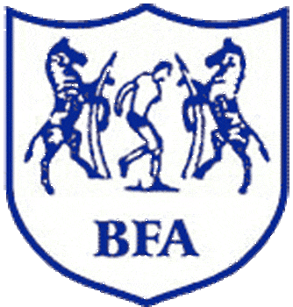
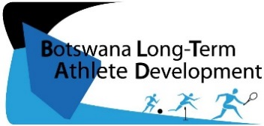

Created 2015
Botswana Football Association
Gaborone Botswana
www.bfa.co.bw
bfa@bfa.co.bw
TABLE OF CONTENTS

- Preface……………………………………………..…………………………………… 3
- BLTAD Football ...………………………………….………………………………… 4
- Grassroots: Kick Start ………………………………………………………………. 7
- Youth: Development ……………………………………………………………….. 10
- Junior: Competition ………………………………………………………………… 12
- Senior: Excellence. ……..….………………………………………………………… 14
- Football For Life …………………………………………………………………….. 16
- Collaboration: On the Ground ………………………………………………….. 17
- Collaboration: From the Top .…………………………………………………… 18
- Appendices………………………..………………………………………………….. 19
Expert Working Group
- Mr Benni Kgomela : Technical Director
- Mr. Tshepo Mpukhuti : Technical Development Officer
- Mr. Ricardo Marape : National Football Coach
- Mrs Barobi Nwako : Women’s Football
- Mr. Modise Mgadla : Liaison Officer-SD&TS, BNOC
- Ms. Jennifer Brown : BLTAD Consultant, BNOC

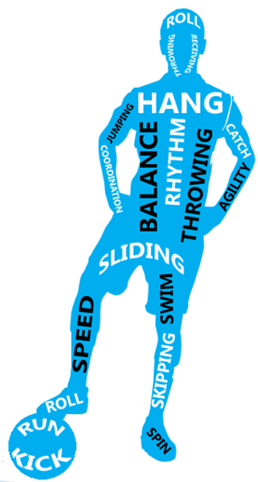
Key Terms
BNSC- Botswana National Sport Commission
BNOC – Botswana National Olympic Committee
BOPSSA – Botswana Primary School Sports Association
BISA – Botswana Integrated Sports Association
BOTESSA – Botswana Tertiarty School Sport Association
CHOPS – Conference Heads of Private Schools
CHIPS – Conference Heads of Independent Schools
ISSSA – Independent Secondary School Sports Association
FIFA – Fédération Internationale de Football Association
FMARC – FIFA’s Medical Assessment Research Centre
Key Stakeholders

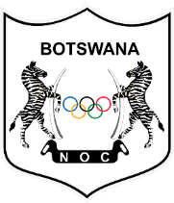
_________________________ _________________________ _________________________
Mr. McLean Letswiti Mr. Solly Reikeletseng Mr. Negroes Kgosietsile
President, BFA Chairman, BNSC President, BNOC

PREFACE

Botswana is currently ranked 104 in the world. However the vision of the BFA are to::
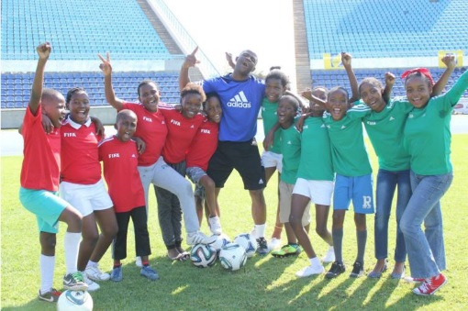
- Make programs accessible and inclusive to all
- Be ranked in the top 50 Countries in the world.
While the immediate response to such goals may appear to be to focus development efforts at the national team, this would provide a short term fix since National players are near the end of their career. Once they are finished, upcoming players from the youth are needed to replace them.
Furthermore, success at the elite level is a product of not only elite level training, but of the training encountered throughout a players lifespan. Without a base, there will be no support for the elite.
Therefore a long-term and sustainable training plan that offers quality development structures at every level through, from grassroots to senior, in a progressive pathway of skills, tactics, fitness, mental focus, and competition is needed to reach the top. As such, BFA’s mission is to have
- More players participating in age-appropriate quality football programs
- A competition structure to meet the needs of players at each stage of development
This can be achieved through the Botswana Long Term Athlete Development (BLTAD): a framework adapted from Canadian Sport For Life (CS4L’s) world leading LTAD that provides age-appropriate guidelines for training and competition of all ages based on scientific and psycho-social principles of growth and development for long term participation and/or excellence in sport (See Appendix A).
However if we want to change the outcome we must change the current process, or system “Insanity is expecting change by doing the same thing.
Also, excellence takes time: results from todays BLTAD may not be witness until 2028 as it takes approximately 10 year to reach the podium. While this takes time, the result will be of better quality than fast track results. Therefore, patience is required for long-term sustainable results.
Furthermore it takes the collaboration of all stakeholders to complete the development strategy. To this, the three associated governing bodies to commit to adhering to the goal of fostering More champions more often, by system rather than by chance, and football participation life.

.
BLTAD: Football

Developing athletes starts from the ground up: from grassroots, to youth, junior, and senior. The Football BLTAD is a framework to training and competition guidelines to guide programs for all ages in Botswana for both football excellence and participation for life.

DID YOU KNOW
Less than 5% of the world elite junior champions medal at the senior elite level
Why: improper development
- Develop to Quickly
- Over train
- Injuries
- Physical Burnout
- Lose Interest
- Mental Burnout
- Limited Support
- Late VS Early Developers
We must not be quick to identify and rush talent. Age-appropriate development is needed at all ages to foster talent.
Football 4 Life
Any Age

Senior: Excellence
Ages 19+ Train to Win

Youth: Competition
Ages 16 -19, Sr Sec Train to Compete

Youth: Development
Ages 12-15, Jr Sec. Train to Train

Grassroots: Kick Start. Learn to Train
Ages 6-12, Primary Fundamentals

:
Kids are not mini adults.
They have a different make up that requires different training, not just less and this make up and training changes with ages.
Training is age- dependent.
Kids learn and grow at different rates. Some kids develop faster than others. Patience and individualized training is needed.
Give all kids time to develop before selection.
.
Development takes time.
The aim is to develop
players to win when they
are elite, at the world stage,
not to win at an early age.
Sacrifice the primary medal
for a world cup medal.

The BLTAD:
Building Tomorrow Starts Today.

OVERVIEW
An overview of the objectives and progression of each stage as well as the associated programs available for these stages can be found below.
Within Botswana, Grassroots development takes place in schools, community and Re Ba Bona Ha programs.
Grassroots: Kick Start
Fundamental Stage/Phase (6-10)
- Introduction to basic soccer skills
- Build overall motor skills
- Modified skills of other sports
Learning to Train (10-12)
- Refining Fundamental Skills
- Soccer Specific Skills
- Combination of skills in game

Schools should include both public (BOPSSA) and private (CHOPS and CHIPS) to be inclusive to all.
Programs from outside include FIFA Grassroots, FIFA’s FMARC’s 11 For Health, and the British Premier Skills Program. The latter two teach life skills and health through football.
Youth programs are available for U13, U15 and U17. Schools have their own teams and can also participate outsider of their school in club teams. Schools include both BISA (public) and ISSSA (private)
Youth: Development
Training to Train (12-15)
- Building the engine
- consolidation of skills
Those who are identified as a higher level of talent are invited to part in camps during the school holidays and/or to train at the Centre of Excellences.
Junior
Training to Compete (16-19)
- Fine tune the engine
- Advance skills, techniques, tactics
Available elite programs include national and regional academies, centre of excellence, school of excellence, high performance centres and holiday camps.
U20, U23, and senior national teams (Zebras) are selected from regional and interregional tournaments. Senior players also play in the Botswana Premiership League in various divisions.
Senior (19+)
Training to Win
- Maximise performance
- Fitness, engine, and tactics
Social leagues and festivals are available for Football 4 All at the adult age while community programs such as Re Ba Bona Ha are for grassroots. Courses are also available for coaching, administrative, officiating and medicine.
Football 4 Life (Any Age)
- Recreational
- Personal Excellence
Administration, Coaching

Training and Competition Structure
In order to achieve our long-term goal we need a systematic method of training and competition rather than hoping it will happen by chance. Every practice must be prepared carefully. However, in reality, we often see coaches plan their session on the way to the field which, in the long term, becomes unsystematic patchwork.
If we are to raise the level of the game in our country we need a stable improvement of technique, tactics, conditioning, and mentality by choosing specific concepts for each training sessions while being cognizant of the age category and slow/faster learners. Below is an overview of training and competition formats per age. Specifics of each age group are in the sections to follow.
Table 1: Training Strucutre
 | Season Length | Training Length | Train:  Comp | Competition Format
Active Start  0-5 | 4 – 16 weeks  1-4 months | 30-45min | N/A | None – informal play
Fundamentals  6 – 10 | 12 – 20 weeks  3-5 months | 30 – 45min | No specific | No league standings – jamborees, emphasis on Fun. All play equal time  All positions
Learn to Train  10 – 12 | 16 – 20 weeks  3 – 5 months | 45-70min | 80:20 | Small leagues with fixtures but no standings. All players equal time and all positions
Train to Train  12 - 16 | Move towards year round | 60-75min | 60:40 | First experience inselect teams. Compete to learn.
Train to  Compete 16 - 19 | Year round | 75-90min | 40:60 | Regula high comeptitions.  Compete for exposure
Train to Win  19+ | Year round | 75-90min | 25-75 | High performance, pro and international. Compete to Win
Table 2: Game Structure
 | # of Players | Time  (min) | Goal Size (m) | Ball Size | Field Size
Fundamentals  6 – 10 | 3v3  4v4  5v5 | 2x 15 | 1.53 x 2.44 | 3 or 4 | 18-22 x 25-30  20-25 x 30-26  25-30 x 30-36
Learn to Train  10 – 12 | 6v6  7v7  8v8 | 2x25 | 1.83x4.27  1.83c5.49  1.83x5.49 | 3 or 4  4  4 | 30-36 x 40-55  30-36 x 40-55  42-55 x 60-75
Train to Train  12 - 16 | 8v8  9v9  11v11 | 2x30  2x35  2x35 | 1.83x5.49  1.83x5.49  2.44x7.32 | 4  4 or 5  5 | 42-55 x 60-75  42-55 x 60-75  FIFA Regulation
Train to Compete  16 - 19 | 11v11 | 2x40  2x45 | 2.44x7.32 | 5 | FIFA Regulation
Train to Win 19+ | 11v11 | 2x45 | 2.44x7.32 | 5 | FIFA Regulation

Grassroots: Kick Start

A National team cannot be strong without strong grassroots
FUNdamental (6 – 10) and Learning to Train (10-12)
The main objectives of Grassroots is to learn the basics of sport that will allow them to keep them active for life:
- FUN and Mass Participation for ALL
- Overall Motor Skills
- Basic Football Skills
- Basics of other Sports
Motor skills and football skills can be found
in Appendix C.

Youth: Competition
This the childs first exposure to footbal and is a critical component to future results. The goal is not necessarily to win, but to build a base for future football success through FUNdamental Movement and Sport Skills in ALL sports, and ALL positions.
This will allow them to participate in a wide range of physical activity and sports that will also contribute to their holistic development as an athlete. The goal is also to have fun and enjoy sport: no matter how talented the child, if they do not enjoy the sport, they are not likely to continue.
Moreover, this is the Golden Stage of LEARNING – children’s brains are developing quickly and they are easily able to easily pick up new skills. Therefore, the focus of the stage should be on development and the ratio of training to competition should be 80 – 20 while participating in a range of sporting activities.
Competition should be used as a fun method of building enthusiasm. Focus on the experience over winning; award creativity, effort, and skill development over results.
Festivals | Round-robin play; skill development  stations; success for all
Schools | BOPSSA’s Inter Zonal, Inter Regional & National Champs, CHOPS, CHIPS
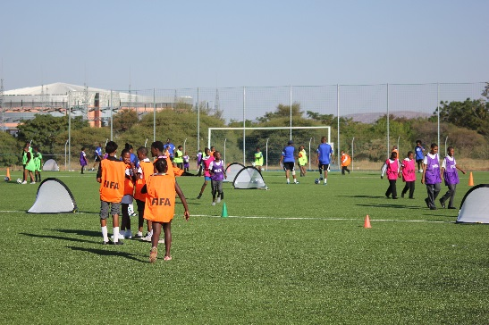
REMEMBER:
The experience is more important than the winning.

At this age, a child’s brain is developing quicker than their physicality. This an optimal time to develop coordination, leg speed, agility, and to learn new skills. They are also fearless and open to learning new things. Their physicality however is developing slowly – they do not have the capacity to properly develop physical fitness such as long speed, strength and endurance. These component should wait until after puberty.
Grassroots: Physical Training Considerations
General Tips:
- Player must be encouraged to use both legs with head up at all times.
- Motor skills training must be incorporated in every session.
- Players should be encourages to play multiple sports (3-4)
- Players should play multiple positions: keep roles general (front/back; right/left)
- All the players should be involved in all workouts throughout the season
- All players should be treated the same, ideally giving each the same amount of attention.
Stage 1: FUNdamentals (6-10)

Stage 2: Learning to Train (10-12)

Objective
- Refining Motor Skills
- Football Specific Skills
- Use skills in game-like activities
Objective
- Mass Participation
- Motor Skills
- Intro to Football Skills

Motor Skills (FMS)
Advancing FMS from stage 1 as needed. Trained through FSS,

Motor skills (FMS)
Running, Jumping, Throwing, Dodging, Twisting, Stopping, etc.

Basic Football (FSS)
- Fun games with the ball to just get a feel.
- Small-sided games
Up to 5v5

Basic Football (FSS)
Dribble, Passing, Control in through repetition and challenges
,

FSS in Game Activities
- Small Sided Games (up to 9v9)
- Principles of Play
- Simple tactics (marking, spaces)
- Introduction of Rules/ethics
FSS in Game Activities
Minimal – only when done in FSS
,

Physical fitness should focus on short speed and flexibility.
Deliberate training at this age is not needed:
fitness will be trained through skill development and games

Grassroots: Psycho-Social Teaching Considerations

By nature children are more curious and love being active. But they quickly become impatient. This is before puberty stage, their perspective is completely self-centred. In other words they think the whole world revolves around them.
As they get older, especially after the age of 10, they learn to look beyond themselves. This gives them a different understanding of their teammates, of positions and of formations (Defence, Midfield, Attack) They learn to think more in the long term and work systematically towards success.
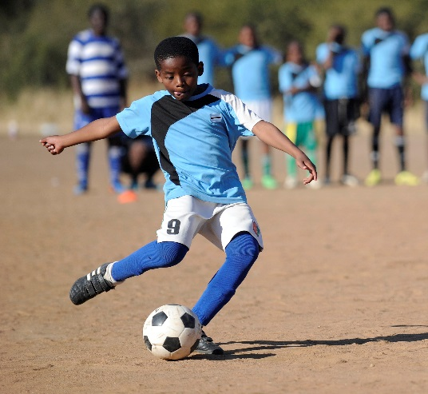

Stage 1: FUNdamentals, 6-10 yrs

KIDS ARE…
Creative: Let them explore and invent games/rules
through free play
Ego-centric: Provide maximum ball time and emphasis cooperation and team work
Restless: Keep instructions simple and sit-time short
Sensitive: Give positive encouragement and
provide ways for success
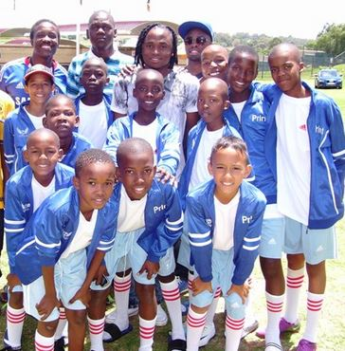
Stage 2: Learning to Train (10-12 yrs)

Less ego-centric: Reinforce team work and build connections:
- i.e., passing VS dribbling; relays and partner drills
- Use symbols of commonality (bibs)
More reflective & self-aware: Allow decision making, teach through understanding and activities needing concentration,
- Provide a variety of methods but let them discover find their own solutions: Learn by doing and from mistakes.
- Debrief: self-assessment & “What did you learn today”
Compare to others: Be a role model & develop at own pace.

Other Considerations:
Parents play a large role in the child’s life. Support your children: attend games, be a role model, Education should be balanced with sport from a young age as the two complement each other.
Culture of sport should be development where it is fun to move, sweat and get dirty.
Tolerance and knowledge of other cultures, religion and believes to be taught and all play together.
Safety concerns and policies should be taken for child protection
Life skills such as health and respect should be taught.
YOUTH: Development

The youth age is an important transition to the elite level: it is important not to rush development.
90% of the world eventual top players were NOT successful at the youth age
Train to Train (12-15)
Main Objective: Build the engine and consolidation of skills.
Adolescents go through an important growth stage at this age: puberty. They experience an internal conflict between loss of childhood and an aspiration to join the world of adults. It is often difficult for coach, in particularly because early of late development causes additional problems for some players. At the same time, it is an important foundation for development of their personalities, which mean they need plenty of help and support from the coaches and society at large.
Youth: Physical Considerations
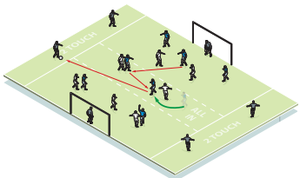
- Skills: consolidation of basic skills into game situations and tactics
- Tactics: Introduction of basic elements
- Positional Awareness: introduction and consolidation of skills and tactics of all positions.
- Small-Side Games- up to 11 V11
- Physical Development: Introduce basic functional training through aerobic capacity and body weight strength.
Players also go through both growth and psychological changes with puberty:
Body Structure: Height, stature, and limb length could changing meaning that they may now be better at different sport or position than they were previously. Players should train all aspects of the game before puberty to account for such changes and should be re-evaluated after puberty.
Coordination: Some players’ structure change so rapidly that they may need to relearn skills that they once had masters because they are no longer used to moving with a longer set of limbs. Coaches must be patient during this time
Personality: Players response to coaching, and interest in sport may change

For these reasons, talent ID should be delayed until AFTER the growth spurt
(see next section)

Youth: Psycho-Social Teaching Considerations

Youth: Competition Considerations

Mental Skills | Establish a pre-competitive routine for mental prep and introduce goal setting, imagery, self-talk, the ability to cope with results and long term training objectives.
Team Work | Encourage team work and team bonding on and off the field to avoid peer pressure and bullying. Teach respect for genders
Discovery | Encourage trying new things – they may be nervous to try new things than children
Responsibility | Give players more responsibility both on and off field. Start treating players more like partners in a collaborative coaching environment
Individuality | Treat everyone in the same way while providing individual encouragement and recognizing individual development rate
Tolerance | Be tolerant of mood swings, outside distractions, influence of peers, or rebelling. Watch for changing behaviour and growth (be more sensitive
Balance | Adolescents may be focusing on academics, have new interests and may be pressured by their peers to try new activities. Rather than denying them this oppourtunity, let them try other activities giving them days off and encouraging a balanced lifestyle but encourage commitment to the sport.  This is the highest drop-out rate, particularly for girls. Provide them with a role model, so that it is “cool” to be in sport.
Life skills | Act as an role model and advise on life skills (i.e., avoid drinking, drugs, smoking etc.,)
Competition
Introduction to competition with a focus on LEARNING.
Winning is not important at this stage; before a child can win, they must be given a chance to learn and develop. Pressure to achieve quick results will rush development, forcing athletes to develop few specialized skills that allow them to win early but limited hollistic develop that will help them win later: when it counts.
A balance of training to competition is needed: 60% Training : 40% Competition
Too much competition  May limit the full potential development of FUNdamental skills and force players to try skills that they are not proficient in under pressure. This may result in low self-esteem and confidence. | Too much training  Competition is necessary to learn how to apply mental and physical skills and tactics against opponents and in pressured situations. However, this competition should have a LEARNING focus rather than win at all cost.

JUNIOR: Competition

Experience at the high performance level is needed before winning at all cost.
Train to Compete (16 – 19)
Main Objective: Fine tune the engine, advance tactics and skills and exposure to high performance competition.

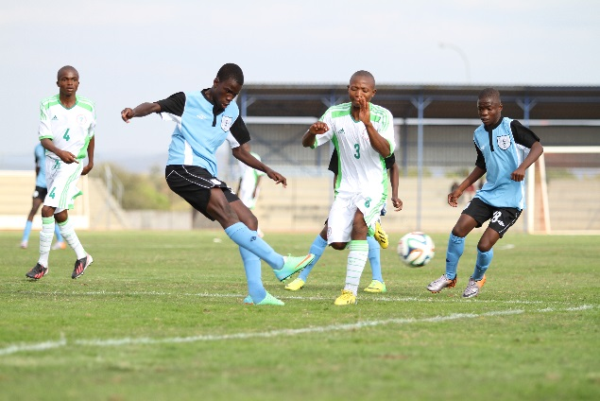
Junior : Physical Considerations
- Skills and tactics: consolidation of ADVANCED skills and tactics under pressure of time, space, and opponent.
- Tactics: decision making, game appreciation, analysis, competitive proficiency
- Positional Awareness: specialized positions
- Physical Development: Optimize all physical fitness components
Caution transferring to big clubs too early because they may not get as much playing time and attention if still a developing athlete
Junior: Pyscho-Social Considerations

Mental Skills | Optimizing mental preparation, self-talk and imagery
Mental Strength | Increasing mental maturity and self-awareness and criticism. Work on emotional stability in pressure, player responsibility, discipline, & goal setting
Independence | Encourage independence and responsibility over their own athlete life and let them be part of structuring their training program. Train them to assess themselves and keep performance records/journals while giving feedback.
Team Work | Encourage team work and team bonding on and off the field to avoid peer pressure and bullying. Teach respect for genders
Balance | Allow for balance of school, social and career development activities while assisting with sponsorships for tertiary education.
Life skills | Act as an role model and advise on life skills (i.e., avoid drinking, drugs, smoking etc.,)

on
Junior: Competition

Exposure and experience in high level competition. Note that this competition is not a win at all
cost but to gain experience so that they are ready to go for excellence in the next level (senior).
International Competition: Athletes as this level participate in international competitions African Youth and Junior Championships, World Youth and Junior Championships for experience for the senior level.
Variety: Learn to play in a variety of setting and how to adapt to changing demands.’
The ratio of training to competition should progress to 40: 60.
Talent Identification
Talent Identification for national teams should be delayed until after puberty (i.e., sr. secondary school) to truly identify talent as it may be difficult before the athlete’s body, and thus talent, will change soon as well.
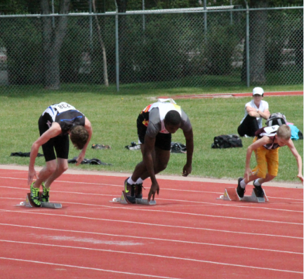
Talent should be identified based on potential talent
Potential Talent
who will be good later
Current Talent
who is good now
VS
For instance, the athletes on the right are all the same age. Though the athletes on the right may be slower now because of his size, he may be faster once he passes his growth spurt. He shows potential talent because he displays correct technique but lacks strength, so that once he grows his power may be used in a correct way.
Other identifiers include mental and cognitive aspects as the ability and willingness to learn new skills, the motivation to train, and the ability to perform under pressure (see Appendix D for more).
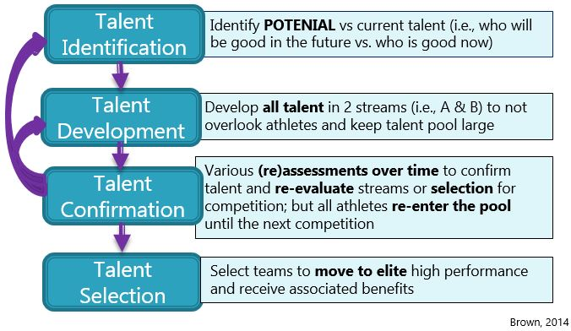
Talent should be
re-assessed
overtime in a process rather than a one-time trial.

Senior: Excellence

Success at the elite level requires the integration of skills and services
Train to Win (19+)
Main Objective: Maximize performance, engine and tactics
This is the final stage of the athlete’s competitive career. They have learned their basics (grassroots), consolidated their skills (youth)) and advanced those skills at youth elite. It is now time to fine-tune their skills and optimize their fitness and mental toughness to aim for excellence at the elite level.

Elite: Physical Considerations

- Skills and Tactics: maximize and fine-tune position specific skills and tactics

- Physical Development: Maximize fitness through high intensity, individualized, specialized training with appropriate rest
- Games: Adapt to changing environment
- Competition: aiming for excellence at the elite level.

Elite: Psycho-Social Considerations

Mental Skills | Optimize mental preparation, self-talk and imagery, focusing
Independence | Encourage independence and responsibility over their own athlete life and let them be part of structuring their training program. Train them to assess themselves and keep performance records/journals while giving feedback.
Support Services | Provide integrated support servies both at home, during training, and away on comptition. (i.e., physiotherapy, nutrition, psychology, career planning etc.,)
Balance | Allow for balance of football, school, career and family planning
Life skills | Advise on time, meda, and agent management, public speaking skills, and anti-doping education

Athlete Retirement

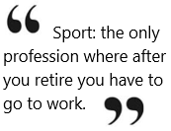
The next step in the cycle after elite excellence is athlete retirement. Athlete retirement can be one of the hardest transition stages in the development cycle. If an athlete identifies with being only an athlete and has no other skills to transition from sport, it can be difficult to continue with a career.
Athletes should be provided time and assistance for financial planning and professional development to prepare for retirement transition while noting that appropriate time away from training may also benefit performance by keeping the athlete fresh and avoiding mental burnout.

Football 4 Life

The key to long term retention in sport is not only about whether the person developed the skills to play but weather they had a fun, positive, and safe experience in sport.
Football 4 Life (any age)
Main Objective: Maximize participation for all interest and abilities and keep player
in the sport post retirement.
While the nation aims to send athletes to the World Cup, only 1% of the population will make the podium. Therefore we need to cater to the other 99%:
Streams
- Recreation: participation for fun, social or health
- Personal Excellence: deliberate practice to improve and achieve personal success
- Non-athletics: coaching, administrating, officiating, supporting (fans), medicals
Beginner Adult: Grassroots practices for beginner adults who wish to learn the game are also need: Community Football.
Women Football: Oppourtunites to entice more women to participate are needed. This could be women’s only leagues or practices as well as providing coaching, administrative, officiating, and medicine courses for women to empower their involvement in football
Oppourtunties for Football 4 Life can come in the formof structured, tier leagues, with both recreatinoal (social) games, and also higher development games.
Players With Disability: All persons have the right to play. Players With Disabilities do not always need separate practices – they can train with abled-players if the environment is welcoming, positive, and inclusive. While some trainings would need modifications, these modificatinos will also be beneficial to abled bodied athletes i.e., increases the difficulty of a drill if one leg, one arm, blind folded, etc.

Collaboration: On Ground

Long term participation and success depends on everyone.
Coaches
Parents
Teachers

Team Work

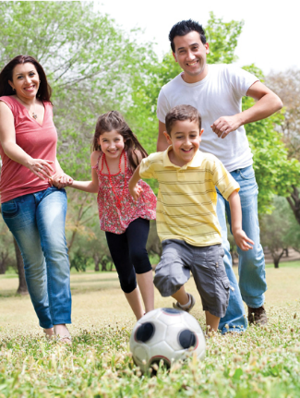
Parent – The Supporter
- Support: Moral, Emotional, Financial
- Encouragement: make kids fall in love with football
- Fun: focus on personal improvement over results
- Healthy Eating: for growth and development
- Balance: education and sports (sports help education)
- Teach: good habits, discipline, responsibility
- Role Model: teach sport as a healthy lifestyle

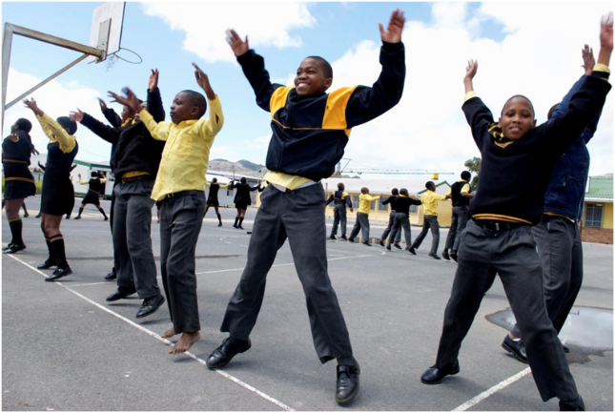
Teacher – The Guide
Children spend most of their time at schools.
They play an important role in child development
- Training: Train teachers on
  - Basic and advanced coaching
  - Age appropriate training
  - Age appropriate competition
  - Team Selection and Talent Identification
  - Train teachers on diet and nutrition
Coach – The Specialist
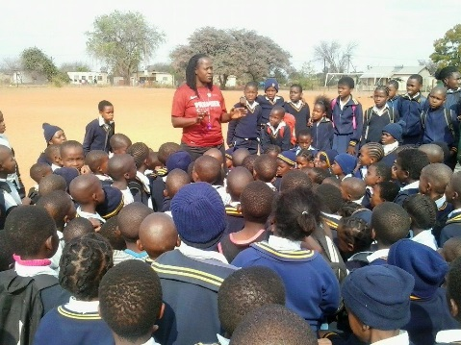
- Training: Attend courses of player development
- Knowledge of:
  - Coaching different levels of players
  - Talent identification
  - Age-appropriate competition
  - Holistic development
  - Support services: i.e., nutrition, rehabilitation, psychology etc.,
COLLABORATION: On Top

Though the stakeholders on the ground (parents, teachers, and coaches) have immediate impact on the players’ development, this is guided by the stakeholders at the top (team management, national federations, government, etc).
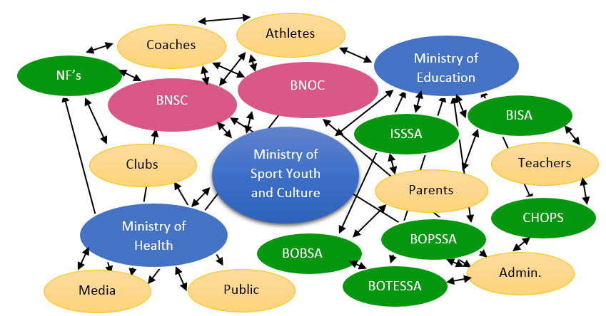

THE BLTAD
A collaboration
among all
Batswana to foster
an active and
competitive
nation

For instance, even if the coach adopts the BLTAD philosophy of developing first to win later, if their governing bodies are paying or recognizing them based on results they will be forced to neglect the philosophy of doing the right thing in order to please their authorities. Moreover, some governing bodies even instruct their development coaches to follow BLTAD but yet reward results.

While it is fine to recognize and reward results at the elite level where this is the objective, coaches at the grassroots and development level should be recognized based on the objectives they are meant to achieve: development. In other we need to send a consistent messages to coaches by doing our part at the top as well.

Role of Governing Bodies:
- Provide education to stakeholders on ground and at the top
- Implement age-appropriate program structure
- Implement age-appropriate competition structure
- Develop a national structure that provides a clear pathway of progression from grassroots to podium and beyond
- Appropriate and standardized talent identification and selection
- Align polices and age-appropriate funding/recognition
- Stakeholder alignment
- Send a consistent message

Appendix A
Botswana Long Term Athlete Development Model
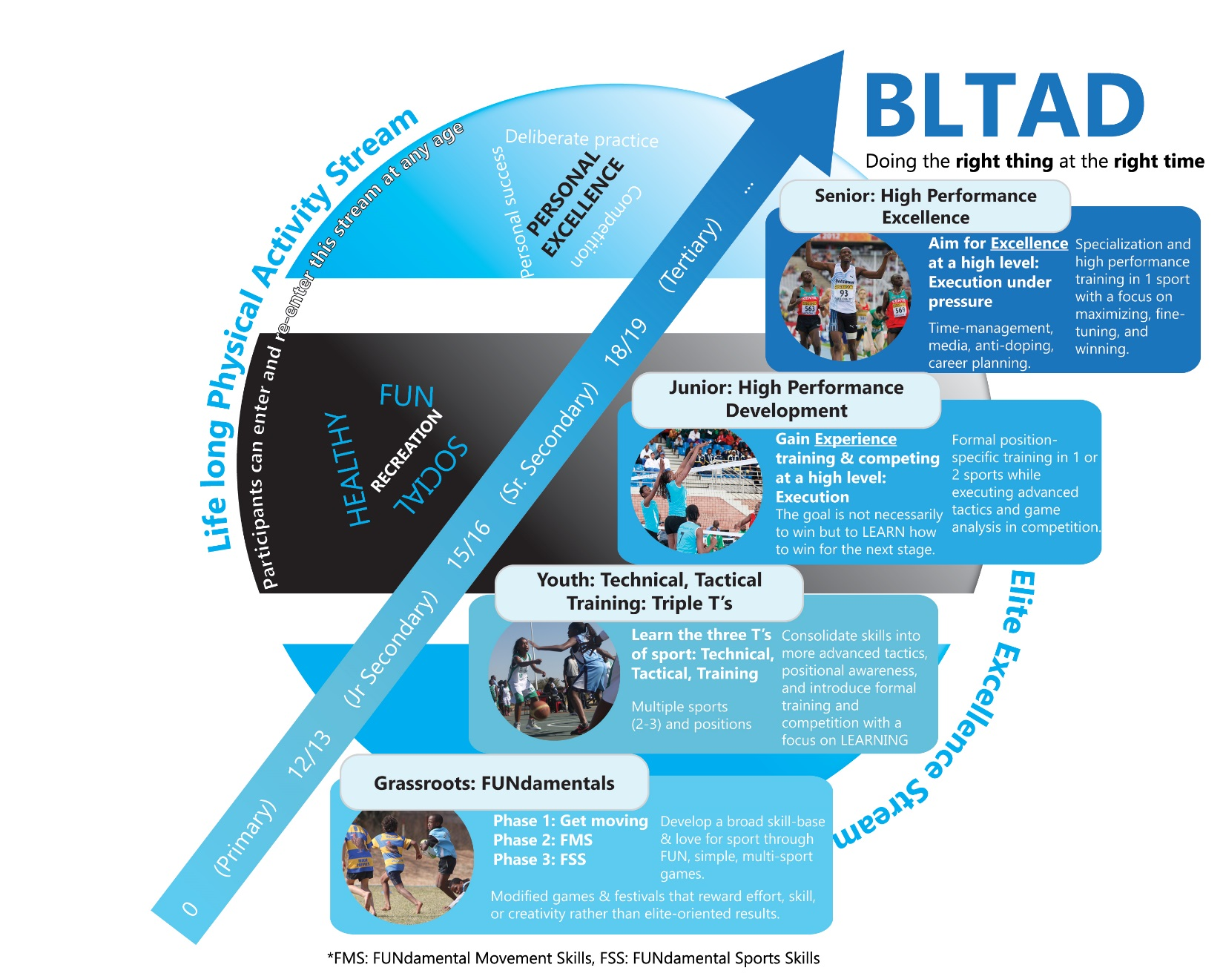
Figure 1:

APPENDIX B
Botswana Football Long Term Athlete Development Competency Matrix
The following charts offer suggestion of teaching progressions of various football skills. Some skills can also be included at the higher stage – this a suggestion of when to start and focus on the skills.
MOTOR SKILLS  FUNdamental Movement Skills (FMS) | Active start | FUNdamentals | Golden Learning | Building the engine | Advacned
 | 3-5 | 6-8 | 9-11 | 12-15 | 15-18
Coordination of arms and legs
Run with starts and stops
Run & Change Direction
Acceleration
Explosive first step
Running technique
Gallop
Skip
Back Peddling
Quick feet and cross-overs
Lateral movements (i.e., side steps)
Ready position
Arching
Rolling
Jumps for distance
Jumps for height
Lateral jump
Two foot hops
One foot hops
Jump and make shapes in the air
Jump stride and bound patterns
BALANCE
Balance on a line
Balance on 1 foot (weak and strong)
Balance on an unstable surface
THROW
2 handed over head
Throw 1 hand (weak and strong)
1 handed over hand
1 handed underhand
1 handed side
Catching
KICKING (see technique)

Table 4: Technical Skills (FUNdamental Football Skills)
TECHNIQUE  Football Skills | Active start | FUNdamentals | Golden Learning | Building the engine | Advacned
 | 3-5 | 6-8 | 9-11 | 12-15 | 15-18
Juggling
Dribbling walking
Dribbling running
Dribbling unopposed
Dribbling with an obstacle
Dribbling opposed
Running with the ball
Basic Turns
Advanced Turns
Feints and Dribble
Beating an opponent
Escaping an opponent
Inside foot on ground |  | <20yrd | <20
Instep on ground
Long pass
Chip/lofted pass
Swerve (inside foot)
Swerve (outside foot)
Crossing
Varying distances
Control with foot
Control with thigh
Control with chest
Control with head
Stationary, moving
Unopposed, opposed
Varying distance
SHOOTING
Instep
On Ground
In air
Half Volley
Volley
Quick
1v1 with goal keeper
Varying distances
HEADING
Basic technique
Defensive heading
Offensive heading
GOAL KEEPING
Basic catching
Positioning
Diving
Distribution
Advanced techniques: i.e., crosses, punching,
Communication
Reading the play

Table 5: Tactical Skills
TACTICAL SKILLS | Active start | FUNdamentals | Golden Learning | Building the engine | Advacned
 | 3-5 | 6-8 | 9-11 | 12-15 | 15-18
Throw-ins
Penalty kicks
Corner kicks
Goal Kicks
Free Kicks
Attacking as an individual (1 v 1)
Attaching in pairs (2 v 1, 2 v 2)
Attacking in small groups (3’s & 4’s)
Attacking as a unity and team
Support with the ball
Support without the ball
Attacking set plays
Crossing balls in the penalty box
Attaching from wide positions
Transition and counter attacks
Finishing
Communication
Positional play
Defending as an individual (1 v 1)
Defending in pairs (2 v 1, 2 v 2)
Defending in small groups (3’s, 4’s)
Defending as a unit & team
Covering
Applying pressure
Supporting
Recovery
Communication
Transition from defence to attack
Defensive set plays
Positional plays
Balance/ depth in defence
GAME RULES
Individual & Team behaviour
Field & Equipment
Restarts
Fair & Foul Play
Basic Rules
Free kicks – offside, direct, indirect
Misc. rules – advantage, hand ball, etc.

Table 6: Physical Conditioning
PHYSICAL CONDITIONING | Active start | FUNdamentals | Golden Learning | Building the engine | Advacned
 | 3-5 | 6-8 | 9-11 | 12-15 | 15-18
Dynamic Warm-up |  |  | Games | Formal
Flexibility
Short speed
Anaerobic stamina (long speed)
Aerobic Stamina
Body weight strength
Core strength
Plyometric
Weight training
Table 7: Mental and Cognitive Conditioning
MENTAL and COGNITIVE CONDITIONING | Active start | FUNdamentals | Golden Learning | Building the engine | Advacned
 | 3-5 | 6-8 | 9-11 | 12-15 | 15-18
Confidence
Concentration (focus, visualization, self-talk)
Commitment
Composure
Creativity (free-play, decision making, play awareness)

APPENDIX C
Figure 2: BFA’s Criteria For Player Assessment

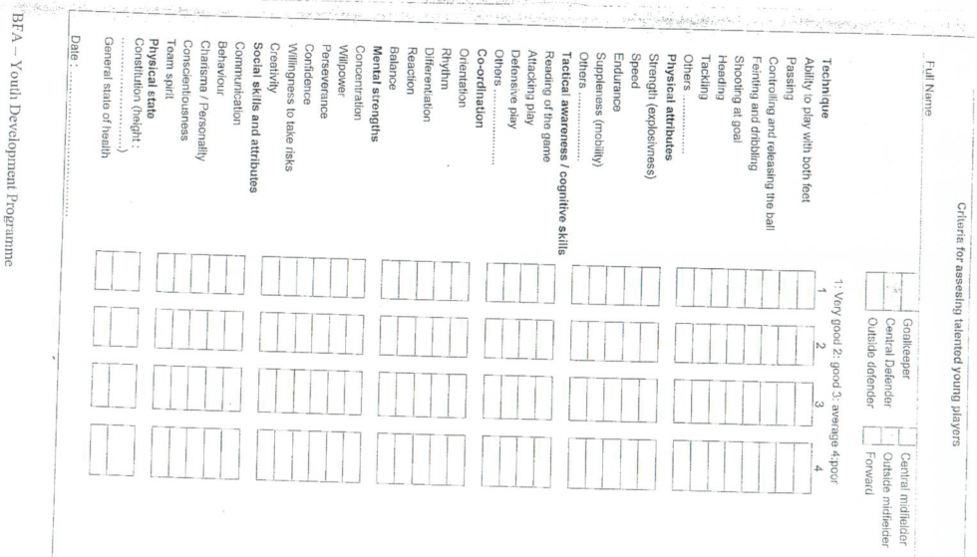

Appendix E
APPENDIX D
Talent Identification
Table 8: Potential Talent
Potential Talent
Ability to learn a new skills | Innovation | Confidence
Responsiveness to training | Problem Solving Skills | Concentration
FMS/FSS | Decision Making Skills | Determination
Sense of observation | Adaptive Strategies | Perseverance
Sense of judgement | Willing to improve (growth vs win) | Environmental/social factors
Tactical Awareness | Attitude | Self-management
Spatial Awareness | Sportsmanship | Self awareness
Effort | Responsibility | Enjoyment (intrinsic motivation)

Figure 3: Talent Identification Model

